**Assignment 3**

**Federated Learning**

**Hongyi Hao**

## 1. Questions

1. Initialize and train a new model using each of the specified hyperparameter configurations. For each run, plot the training loss versus the number of epochs, and report the training and test accuracies. Each run is expected to complete within 5 to 30 minutes, depending on your computer’s specifications.

(a) 15pts: batch size = 32, num communications = 50, learning rate = 0.1, num workers = 2, num local steps = 5.

(b) 15pts: batch size = 32, num communications = 50, learning rate = 0.1, num workers = 4, num local steps = 5.

(c) 15pts: batch size = 32, num communications = 50, learning rate = 0.1, num workers = 8, num local steps = 5.

(d) 15pts: batch size = 32, num communications = 50, learning rate = 0.1, num workers = 4, num local steps = 20.

## 2. Coding Task

2.1 Finish the Training Function for Each Worker

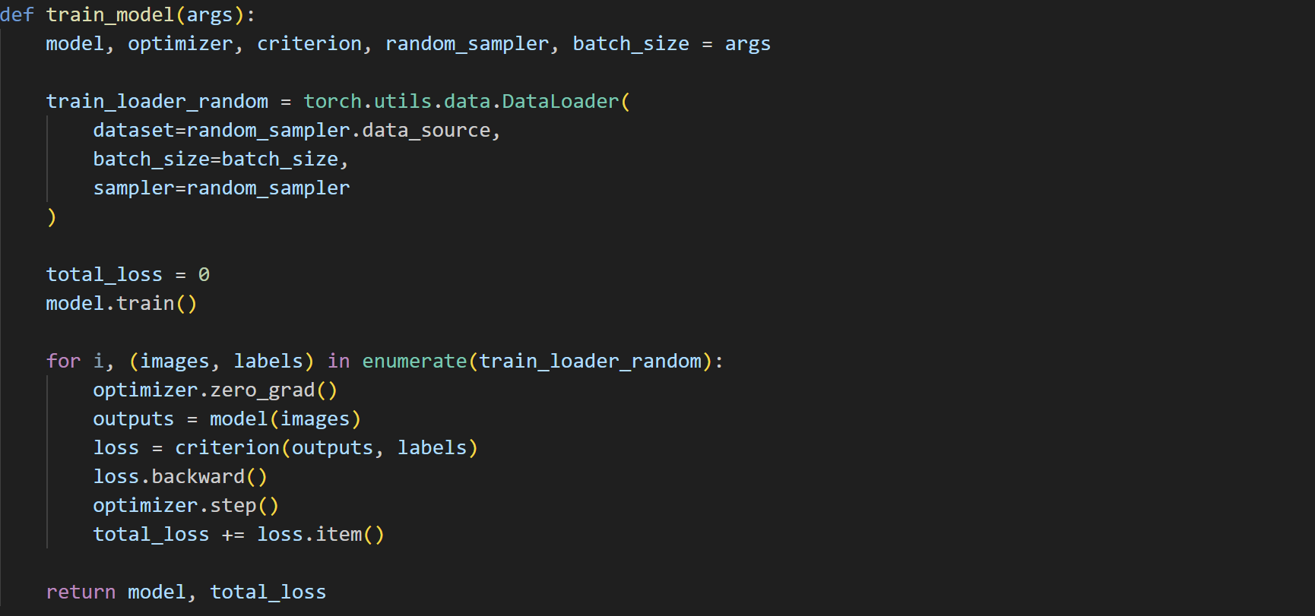

2.2  Finish the Training Loop

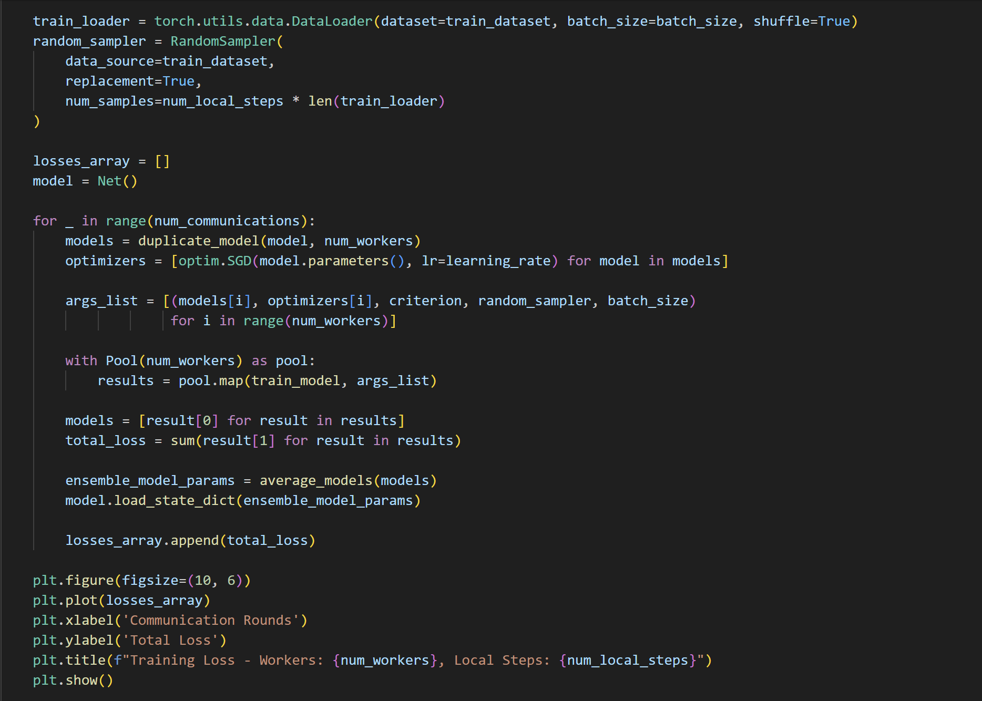

2.3 Testing the Model

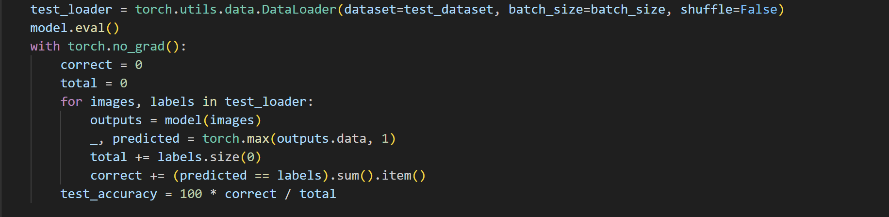

## 3. Question Solution

|  |  |
| --- | --- |
|  |  |
|  |  |

Accuracy:

|  |  |  |  |  |
| --- | --- | --- | --- | --- |
| **Configuration** | **Training Accuracy** | **Test Accuracy** | **Loss Convergence Speed** | **Overfitting Risk** |
| a | 99.81% | 98.38% | Moderate | Low |
| b | 99.93% | 98.24% | Fast | Medium-Low |
| C | 99.94% | 98.42% | Fastest | Medium-Low |
| d | 100.00% | 98.38% | Slow | High |